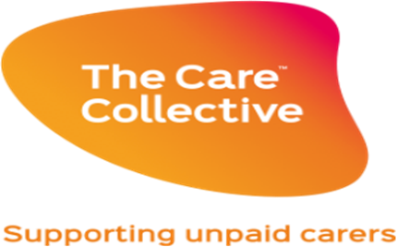

UNPAID CARER’S GRANT SCHEMES – APPEALS PROCESS

What if you are not happy with the outcome of your application?
If you are not happy with the outcome of your application, you can ask for the decision to be looked at again. You will be expected to tell us why you feel the original decision should be reviewed and you may be asked to provide extra information.
The reasons applications are usually not successful are:
- You, or your household, have already received a Carer’s grant from us;

- Living in an area which is not covered by the scheme;

- Not enough information has been provided – this could be your contact details or what you want the grant for; or

- What you have asked for is not eligible under the scheme, or you have asked for cash.
You can ask for your application to be reviewed if you feel one of the following reasons applies:
- The application was unsuccessful because the criteria for the scheme was not met;

- The application was unsuccessful, but you think extra information could change that decision OR something has changed since you applied; or

- Your application was successful, but you do not think enough grant was awarded or you didn’t receive what you had requested.

Step 1: A member of our team will review your case and may get in touch for any information which may help your application. You will be contacted with the decision within 10 working days.
Step 2: If you are still unhappy after Step 1, you can ask for your application to be reviewed by the Head of our Grants Team. This request must be made in writing within 15 days of you having our Stage 1 decision. The Head of the Team will then review the handling and decision of your application. You will be contacted with this decision within 10 working days. There is no further right of appeal following this decision.

If you wish to have your application reviewed, or if you have any other concerns about the grant scheme, please email: info@thecarecollective.wales

